1. **Home page**
2. **Log in / sign up:**

* Existing User: If you already have an account, look for a "Login" or "Sign In" button, usually at the homepage's top right corner. Enter your credentials (username and password) to access your account.
* New User: If you’re new to the site, find the "Sign Up," "Register," or "Create Account" option. You must provide details like your name, email address, and password to create an account.

1. **Search or Browse**
2. **Product Selection:**

* Customize Product: Select product options such as size, color, or quantity.

1. **Add to cart**
2. **View Cart**
3. **Proceed to Checkout**
4. **Enter payment method / Information:**

* Cash (Down payment/In-person), GCash

Home page reference:

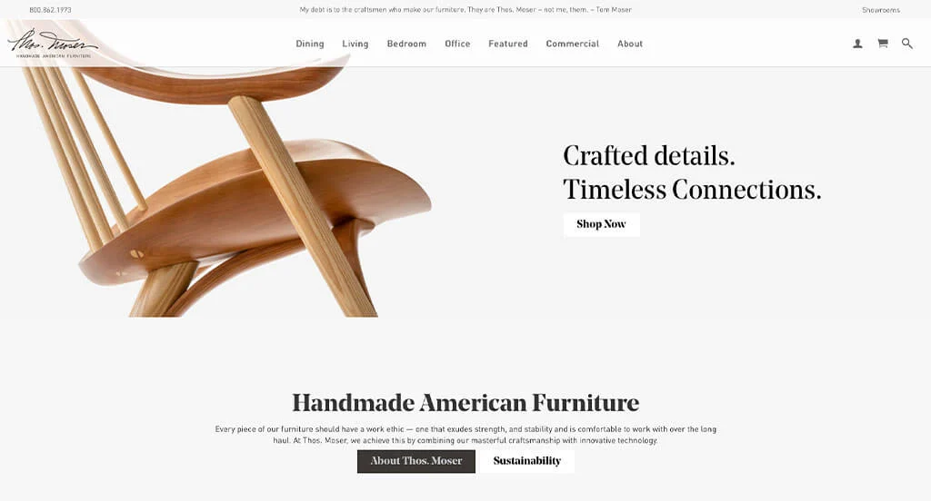

**Figure 1. Reference num 1**

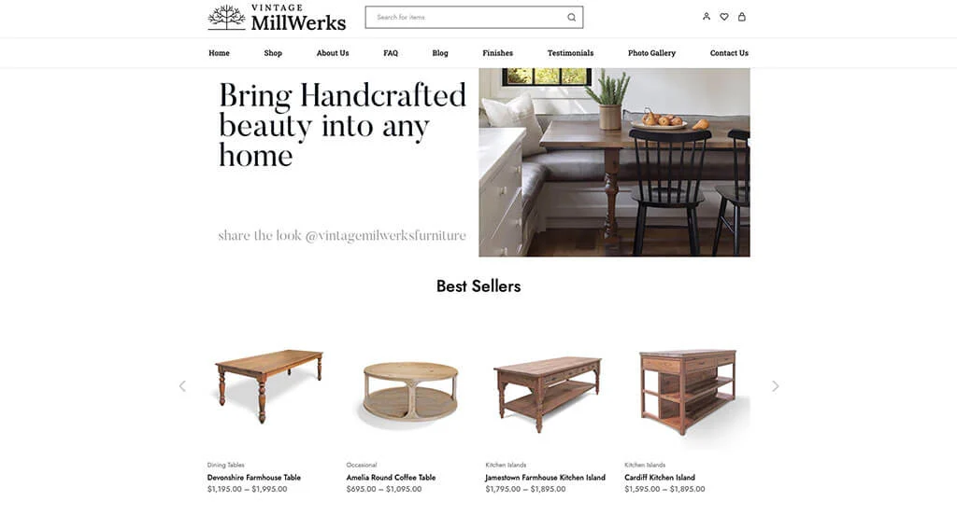

**Figure 2. Reference num 2**

Customize:

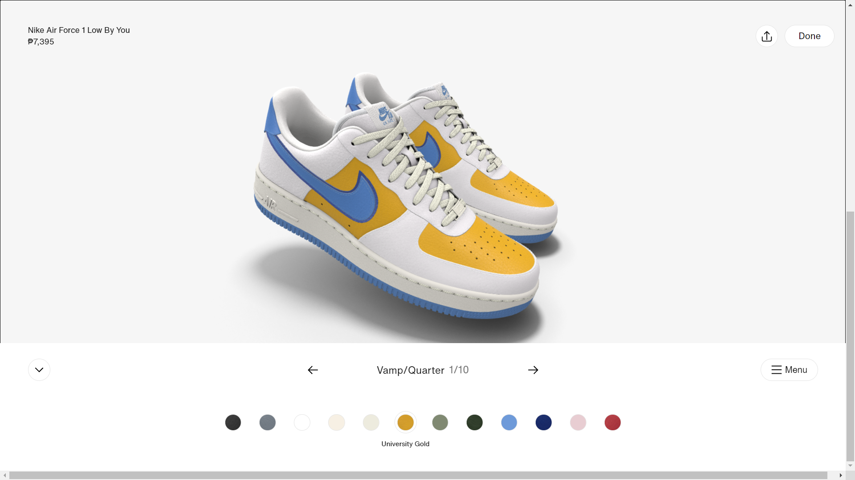

**Figure 3.Reference (Nike by You)**